Request for Proposal

  - Technology Support – 2025 UTTC Tribal Leaders Summit

September 2–4, 2025

Edwin Kitzes
Tribal Leaders Summit Chairperson
February 14, 2025
United Tribes Technical College
3315 University Drive
Bismarck ND 58504
(701) 221-1535
ekitzes@uttc.edu

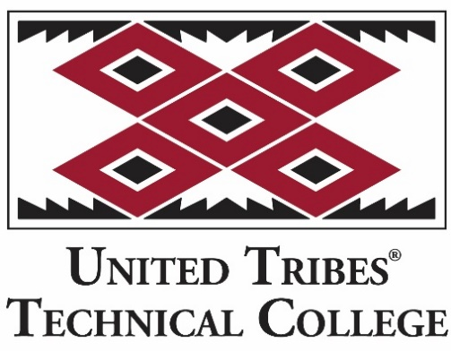

Confidentiality Statement
This document, and any attachments thereto, regardless of form or medium, is intended only for use by the United Tribes Technical College Tribal Leaders Summit. The document may contain legally privileged and/or confidential, copyrighted, trademarked, patented or otherwise restricted information viewable by the intended recipient/s only. If you are not the intended recipient of this document (or the person responsible for delivering this document to the intended recipient), you are hereby notified that any dissemination, distribution, printing or copying of this document, and any attachment thereto, is strictly prohibited and violation of this condition may infringe upon copyright, trademark, patent, or other laws protecting proprietary and, or, intellectual property. In no event shall this document be delivered to anyone other than the intended recipient or original sender and violation may be considered a breach of law fully punishable by various domestic and international courts. If you have received this document in error, please respond to the originator of this message or email him/her at the address below and permanently delete and/or shred the original copy, electronic copy or any attachments thereto and do not disseminate further.
Thank you for your consideration, United Tribes Technical College.
If you have any questions or concerns about the Confidentiality
Statement and requirements, please respond to:
Garrett D. Ludwig, Attorney at Law
gludwig@kelschlaw.com
701-663-9818
Where no notice is given, all information contained herein is Copyright 2025 United Tribes Technical College, Tribal Leaders Summit and Tradeshow.

Submission Deadline
All submissions responding to this request may be emailed or delivered to our office, no later than:
March 10, 2025
5:00 pm CST

Submission Delivery Address
United Tribes Technical College
3315 University Drive
Bismarck, ND 58504
Phone: 701-221-1535
Email: ekitzes@uttc.edu

Electronic Submissions (preferred)
Electronic submissions in response to this Request for Proposal will be accepted if they meet the following criteria:
- Sent via email to ekitzes@uttc.edu
  - Microsoft Word format, or
  - PDF format

Submission Questions and Clarifications
You may contact the following person if you have any questions or require clarification on any topics covered in this Request for Proposal:
Edwin Kitzes
Summit Committee Chairperson
United Tribes Technical College
3315 University Drive
Bismarck, ND 58504
Phone: 701-221-1535
Email: ekitzes@uttc.edu

Business Overview and Background
United Tribes Technical College was founded in 1969 by an intertribal organization, the United Tribes of North Dakota Development Corporation. It is a 501(c)(3) nonprofit corporation chartered by the State of North Dakota and operated by the five tribes wholly or in part in North Dakota. Those tribes are the Three Affiliated Tribes, Spirit Lake Tribe, Sisseton-Wahpeton Sioux Tribe, Standing Rock Sioux Tribe, and the Turtle Mountain Band of Chippewa Indians. United Tribes Technical College serves to provide an outstanding education to the Native American people of this region and around the country. For over 50 years, UTTC has served over ten thousand American Indian students from more than 75 federally recognized Indian Tribes across the nation. In addition to American Indians, the college welcomes and serves students of all backgrounds.
United Tribes Technical College is a regionally accredited institution, having achieved accreditation through the Higher Learning Commission of the North Central Association of Colleges and Schools. The college is considered a 1994 Tribal Land Grant Institution. The College was founded to provide a community in which Indian people can acquire an education and obtain employment. Programs which have been added over the years have kept this initial purpose in mind, providing not only occupational education and training but also individual and social skills in a culturally relevant setting, with an emphasis on children and families.
This year is the 28th Annual Tribal Leaders Summit and Tradeshow. The Tribal Leaders Summit and Tradeshow brings current and future leaders together to discuss the relevant issues facing our tribal nations and citizens.

Assumptions & Constraints
United Tribes Technical College will not be responsible for hotel and travel expenses, all upgrades/modification costs must be discussed and agreed upon by both parties prior to implementation, UTTC reserves the licensing rights to all Tribal Leaders Summit video recordings and photographs.

Terms and Conditions
United Tribes Technical College agrees to pay one half of total agreed upon charges up front for service and final payment upon completion. Vendor must submit a total quote for service rendered and any stipulations vendor may have. Terms and conditions of the contract must be listed in order for the vendor to make a fair and honest response, which may include: financing options, contract length, renewal options, warrantees, delivery penalties, service levels, etc.

Detailed Specifications
This request for proposal is needed for the Tribal Leaders Summit and Tradeshow, a 2-day event. The Vendor who is awarded the contract is expected to provide items including, but not limited to the following:
- Rigging package both audio/lighting system (one (1) stage - main hall)
- Microphones for speakers/presenters on stage
- Microphone, one (1) set up in tradeshow hall
- Lighting package (backlight and stages) with tech support
- Conference video package with 2 screens, stage and tech support
- 2 large screens with streaming video of conference agenda/sponsors
- Hardware requirements
- Round stage – no taller than 22 inches, carpeted, with UTTC logo
- Pipe and drape for backstage
- Recording of main sessions
- Additional request/s may be determined as needed

Selection Criteria
United Tribes Technical College Summit Committee will select Audio/Lighting vendor for the 28th Annual Tribal Leaders Summit. The selection criteria are based upon cost, services, and a cultural understanding of the event. All information will remain confidential.

